**Asteroids Documentation**

*Wajid Uddin 220028395*

**Features Implemented**

* Asteroid bouncing: Asteroids now bounce off each other when they collide, altering both trajectories and speed
* Asteroid splitting: Large asteroids split into smaller asteroids when hit by bullets
* Different scoring: Different points awarded for large vs small asteroids
* Small asteroid mechanics: Small asteroids bounce off the spaceship instead of destroying it

**Modified Files and Methods:**

* **Asteroid.h**:
  + Added BounceWith() method declaration
  + Added GetSize() method declaration
  + Added WasDestroyedByBullet() method to track scoring eligibility
  + Added code to create small asteroids when hit by bullets
  + Added tracking for whether asteroid was destroyed by bullet
* **Asteroid.cpp**:
  + Modified CollisionTest() to allow collisions between asteroids
  + Modified OnCollision() to handle asteroid-to-asteroid collisions
  + Added Bounce() method implementation to handle physics calculations
* **SmallAsteroid.h**:
  + Created new class for smaller asteroids
  + Added lifetime management
  + Added collision handling
* SmallAsteroid.cpp
  + Created Implemented smaller asteroid behavior
  + Added 5-second lifetime limit
  + Implemented bouncing off spaceship
* Spaceship.cpp
  + Modified collision handling to not destroy ship when hit by small asteroids
* SmallAsteroid.cpp
  + Updated scoring system to award different points for large and small asteroids
  + Added logic to only award points for asteroids hit by bullets

**Implementation Details**

**1. Collision Detection**

Modified the CollisionTest() method to allow detection of collisions between asteroids:

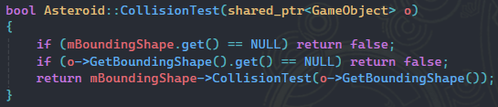

**2. Collision Response**

OnCollision() now detects if the collision is with another asteroid:

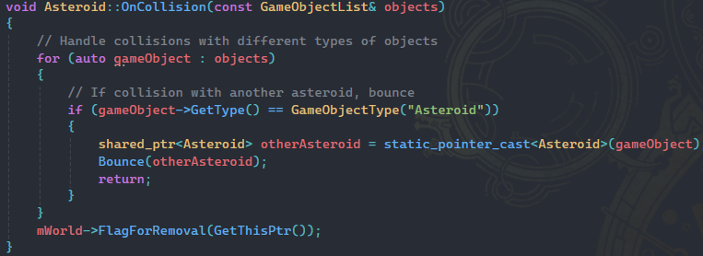

**3. Physics Implementation**

The Bounce() method implements physics for the collision:

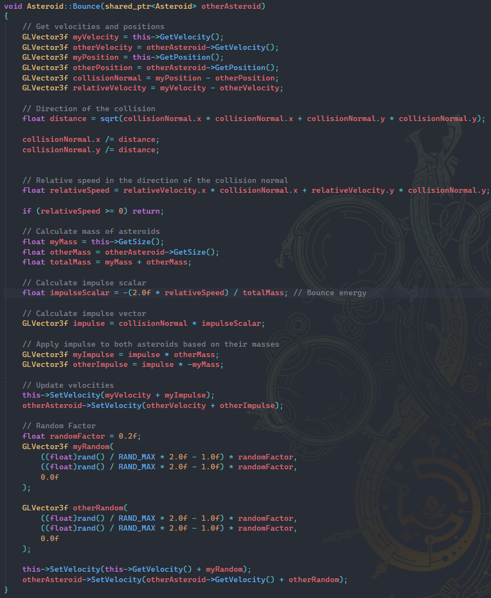

**Screenshots**

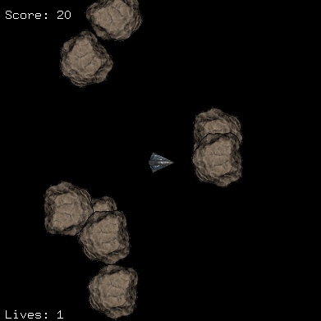

After  
Asteroids bounce

Before (Asteroids would clip through each other)  
Asteroids do not bounce

**4. Asteroid Splitting**

When a large asteroid is hit by a bullet, it splits into 2-3 smaller asteroids:

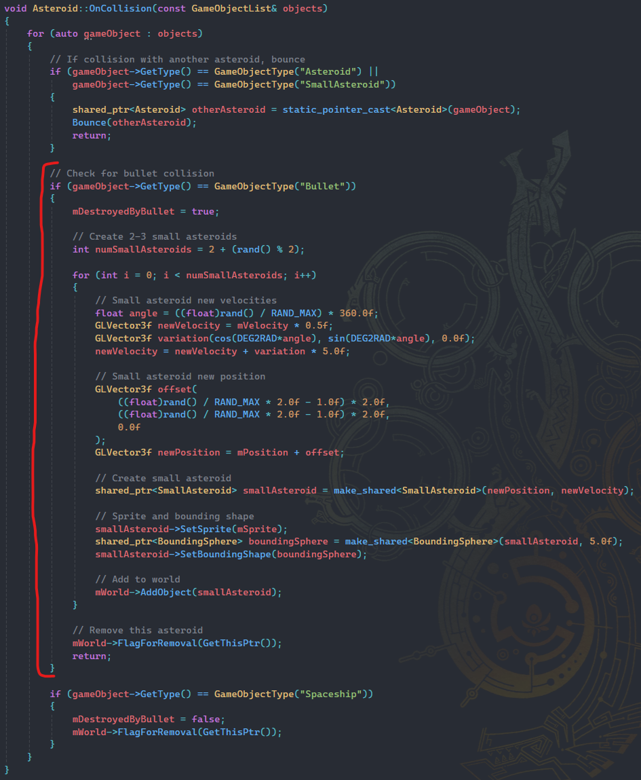

**5. Small Asteroid Behavior**

Small asteroids have a 5-second lifetime (works like bullets) and bounce off the spaceship instead of destroying it:

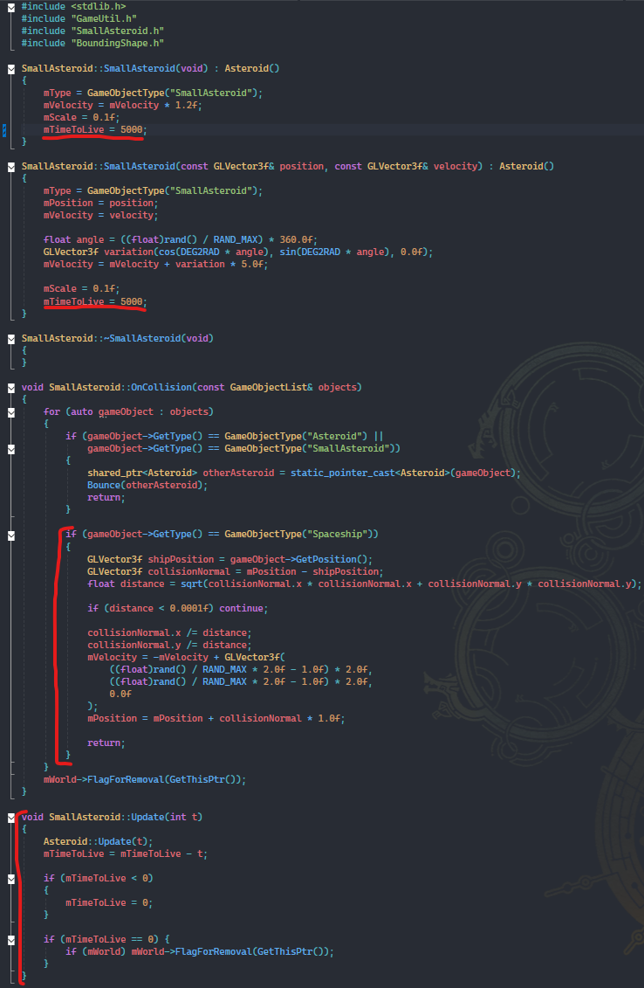

**6. Scoring System** Different points are awarded based on asteroid size, and only when asteroids are destroyed by bullets:

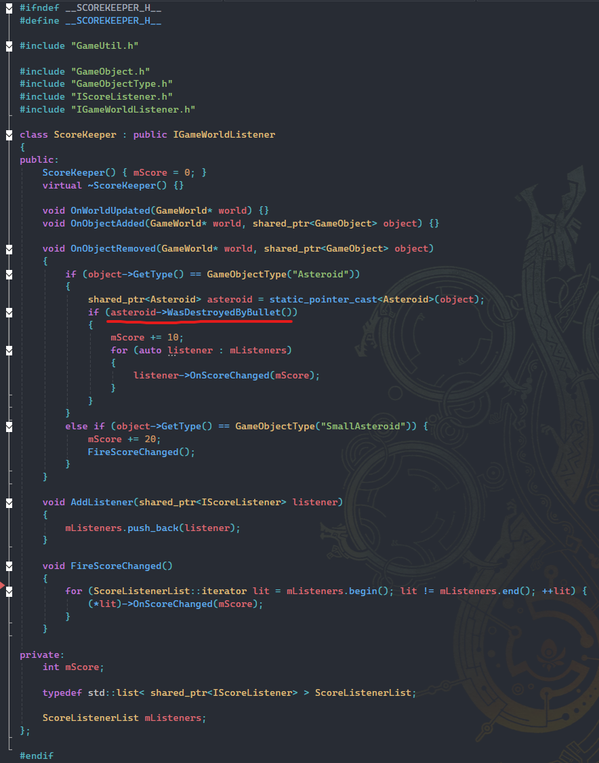

**Completed Requirements**

* "Bounce" off each other when they collide
* Get destroyed when they collide with the spaceship
* Split into smaller asteroids when hit by a bullet
* Small asteroids get destroyed when hit by a bullet
* Small asteroids bounce when they collide with other asteroids
* Small asteroids and ship bounce off each other
* Different scores for hitting large vs small asteroids